# RESTful API (Interfacing with a Server)

REST – Representational State Transfer

|  |  |  |
| --- | --- | --- |
| **HTTP verbs** | **/articles** | **/articles/michael** |
| **GET** | Fetches ALL the articles | Fetches only the article on Michael |
| **POST** | Creates ONE new article | - |
| **PUT** | - | Replaces only the article on michael (ENTIRE, everything gets replaced with new values. Basically replaces entire document and fields not specified are not written) |
| **PATCH** | - | Updates only the article on Michael (PARTIAL, only fields specified are updated) |
| **DELETE** | Deletes ALL the articles | Deletes only the article on michael |

Notes:

To Send GET, POST, PUT etc. requests without a form download and use Postman (<https://www.postman.com/downloads/>)

Requests (use the ‘GET’, ‘POST’, ‘DELETE’ verbs)

Where to enter the route and the data (in the ‘Body’ tab) – a POST request is shown below

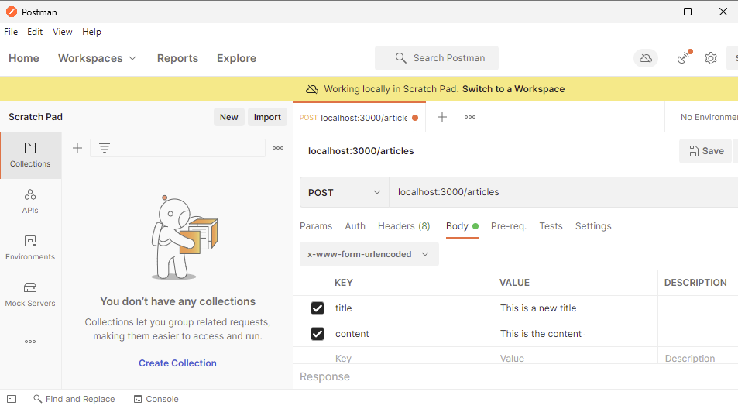

Can view in browser: Add extension to Chrome: ‘Lightweight JSON Viewer’ to view the JSON data provided by the API in a nice way inside the browser.

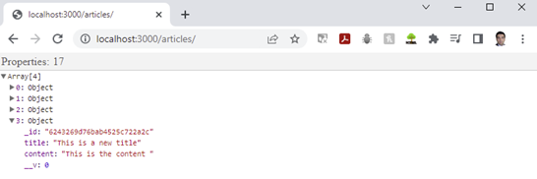

Or use the Body tab of the response to a GET request in postman

